INSTALLATION CERTIFICATE Split System Air Conditioners

Skye Tamarama | Unit Number |  | Street Address |  | 20 Illawong Avenue
Suburb | Tamarama |  | State | NSW | Postcode | 2026
Description of work | Installation of Air Conditioner
Owner Name

Owners may install a split system air conditioning if they meet the conditions of consent to ensure any split system air conditioner system is energy efficient, correctly installed by licensed, insured and competent persons, are adequately plumbed, the external compressor is in the correct location and that owners are responsible for these works, future repair, maintenance and replacement costs.

Details of the Split System Air Conditioner and Cover Installed

Brand
Model
Colour (off white)
Dimension
Energy Rating
(minimum of a 4-star rating)
Consumption
dB Rating
Air Conditioner Cover

Please attach a plan to scale (or a photograph) showing the Air Conditioning is located on the exclusive use space to the West, directly adjacent to the lot it serves. External compressor unit is to be screened no higher than the western balustrade.
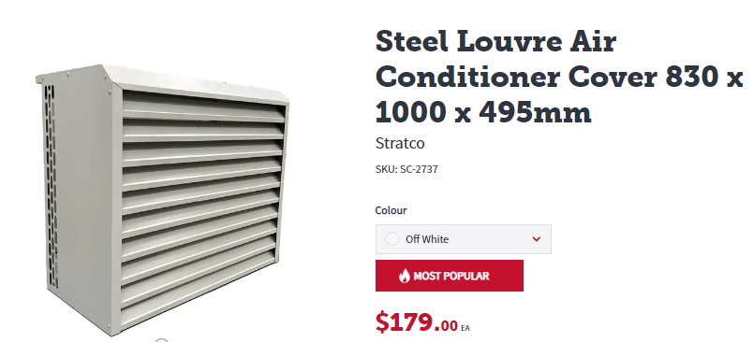

I, the undersigned, certify that:

These work/services described have been inspected and assessed to perform in accordance with the provisions of the Building Code of Australia, the relevant Australian Standards and all other standards of performance required for plumbing work.

In addition, I certify that I am an appropriately qualified and competent person practicing in the relevant area of work. I have recognised relevant experience in the area of work being certified. My company is holding the appropriate and current insurance policy to the satisfaction of the building owner or the principal authorising the installation work being certified.

The following details must be provided in full:
Name |  | Licence No
Company Name |  | ABN
Company Address |  | Phone
Signature |  | Date

